# Answers to Questions from TT 7.2.1

Name: Minh Nguyen

Student ID: 104309099

**Hand execution using a trace table**

*Demonstrate how the following code is executed in the computer.*

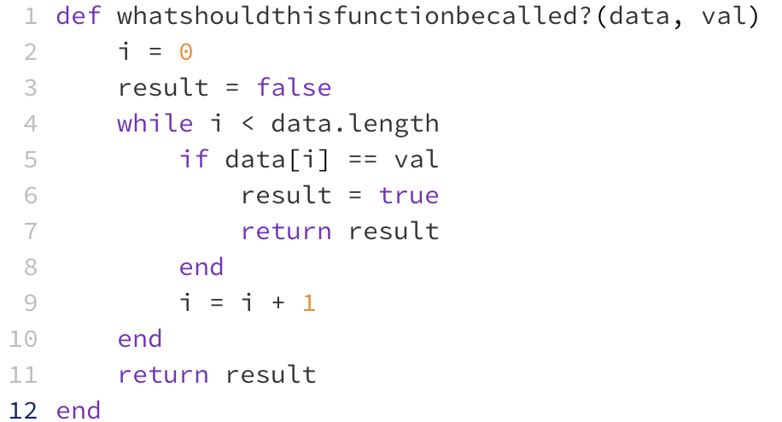

Draw and complete trace tables for the following two sets of data and place the final result in the table below:

|  |  |  |
| --- | --- | --- |
| **Data** | **Val** | **Result** |
| [2, 6, -4, 3, 7] | 3 | True |
| [-2, 8, 2, -5, 9] | 6 | False |

**Once you have completed your trace tables (below) write the name you chose for the function above:**

find_value_in_arrays

**Place your trace tables below:**

For data set: **data** = [2, 6, -4, 3, 7] **val** = 3

|  |  |  |  |
| --- | --- | --- | --- |
| **i** | **Data[i]** | **Val** | **Result** |
| - | - | 3 | False |
| 0 | 2 | 3 | False |
| 1 | 6 | 3 | False |
| 2 | -4 | 3 | False |
| 3 | 3 | 3 | True |
| 4 | 7 | 3 | False |

For data set: **data** = [-2, 8, 2, -5, 9] **val** = 6

|  |  |  |  |
| --- | --- | --- | --- |
| **i** | **Data[i]** | **Val** | **Result** |
| - | - | 6 | False |
| 0 | -2 | 6 | False |
| 1 | 8 | 6 | False |
| 2 | 2 | 6 | False |
| 3 | -5 | 6 | False |
| 4 | 9 | 6 | False |